ENTERING MULTIPLE SECTIONS

Step 1 – Configure ALL line items.
Step 2 – on Line Item Screen select
Step 3 – enter “adds”, hit Get total
Step 4 – Select Quote Sections

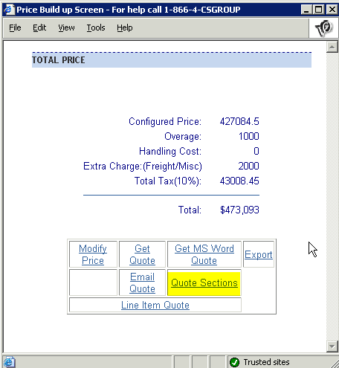

Step 5 – enter number of sections – hit continue.

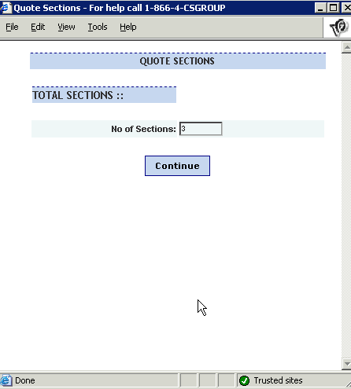
Step 6 – name sections – hit continue
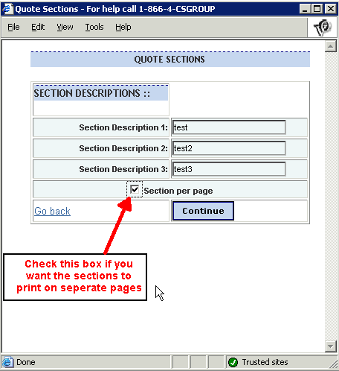
Step 7 – Add standard qualifying notes, standard exclusions notes, or free text notes for each section (if required) – Hit Continue
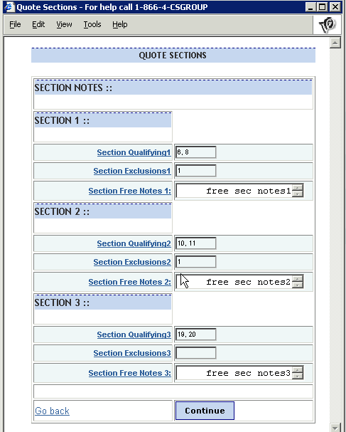

Step 8 – Identify sections with line items – hit continue
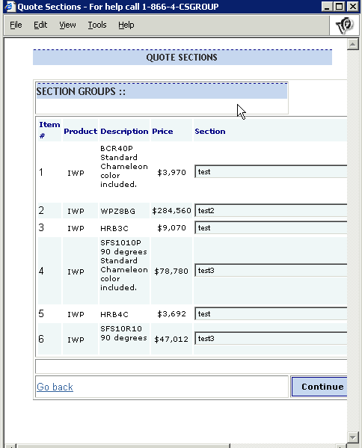

Step 9 – Identify where extra charges should be distributed. Hit continue.

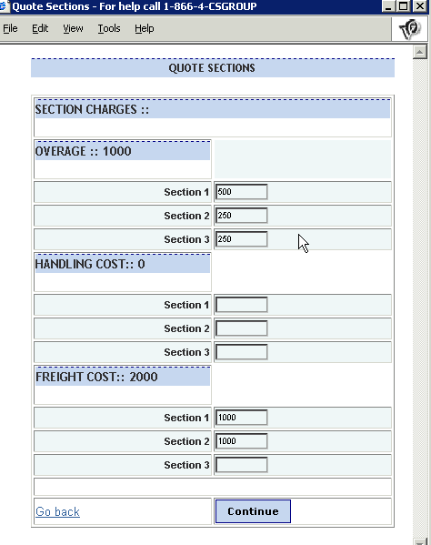

Step 10 – Close Quote sections Window
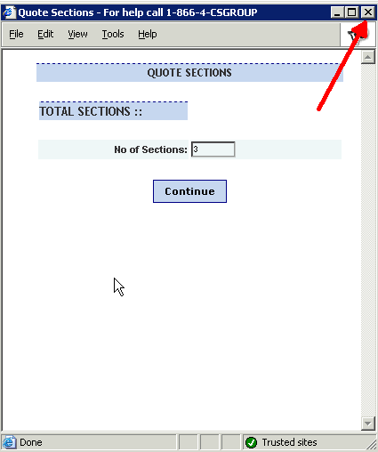
Step 11 – Select quote output.

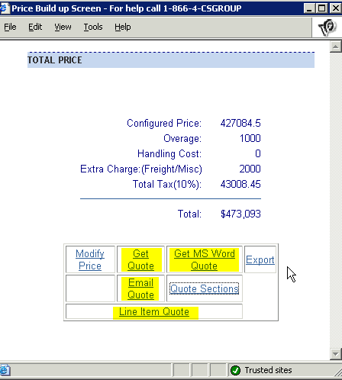

NOTE: If you change or delete line items, change any “extras” (overage, handling, or extra) or remove sections, you must repeat the steps above, or output will be affected.

